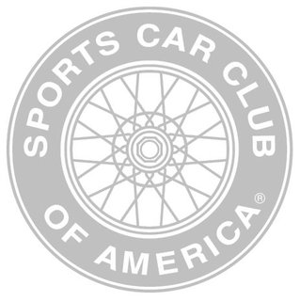
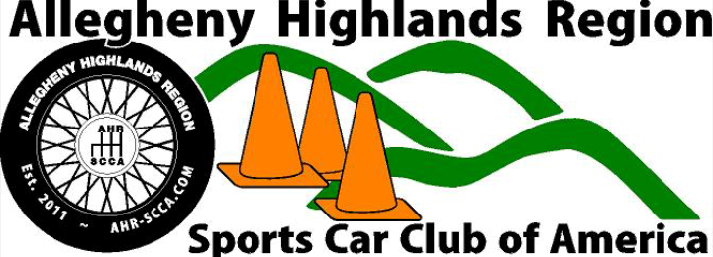
2022
Sponsorship Opportunities

Who is the Allegheny Highlands Region of the SCCA?
The Allegheny Highlands Region of the Sports Car Club of America (SCCA) is an organization of motorsports enthusiasts who host competitive driving events, such as Autocross, Road Rallies, integrated charity events and more.

As a whole, the Sports Car Club of America (SCCA) conducts more than 2,000 amateur and professional motorsports events each year for their 60,000 members (79% male; 21% female) across the country.
The Allegheny Highlands Region of the SCCA has more than 60 members and maintains an average attendance in excess of 150 people per event. As a 501(c)(3) organization, all donations are tax exempt!!

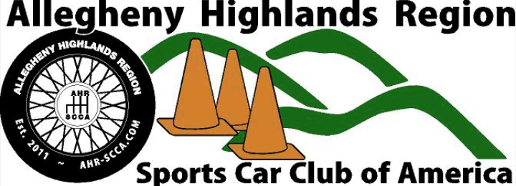
Supporting our Community!
Allegheny Highlands Region members give back to our local communities by making a difference with fundraisers such as:
- Food Bank donations
- Toys for Tots
- “Sophia Rayne’s Racing for a Reason” - a charity dedicated to supporting Spina Bifida research.
- And more!
- In 2021, our contributions to the community totaled more than $2,500 in cash donations alone!
How Does Sponsorship work?
We are excited to offer various levels of sponsorship opportunities in price ranges that any business can afford. From simply supporting the event to showcasing your business as the Title Sponsor, you can be sure to reach a targeted audience of automotive and racing enthusiasts and fans. Your business will be advertised in our region; covering Bedford, Indiana, Cambria and Somerset Counties.
*We are a 501c(3) organization, so your donation is tax exempt! Simply choose a level that works best for you and/or your business!
- We understand that the past few years have been rough on most businesses due to the Covid-19 pandemic. We WANT to advertise and support your business!
- In 2021, SCCA membership, both locally and at the national level has grown immensely. Our events are easily held in adherence to all social distancing mandates, as we are competing outdoors!

Put your business name in the spotlight!
The 2022 proposed forms of advertising by the Allegheny Highlands Region of the SCCA may include, but are not limited to:
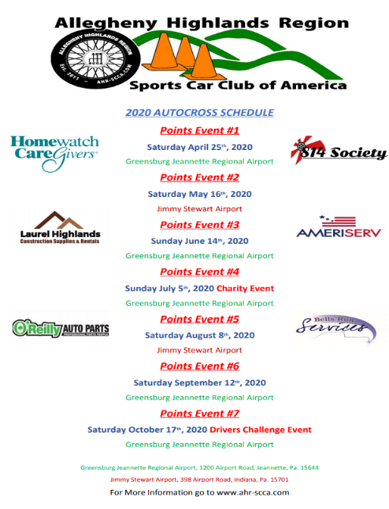
- Apparel
- Posters and Flyers
- Newspaper Listings
- Radio Spots
- Event Announcements over PA System
- Competition Car decals
- Website advertisement
- Brochures
- Business Cards
- AND MORE!!!

Poster Example

Logo requirement for sponsorship
If you choose to sponsor the Allegheny Highlands Region of the Sports Car Club of America (Level 1-7), we ask that you provide some form of your Company Logo, for example, a flyer with a sizeable logo or, preferably, a high quality electronic image file for printing purposes.
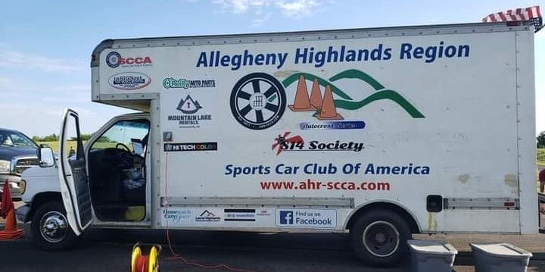
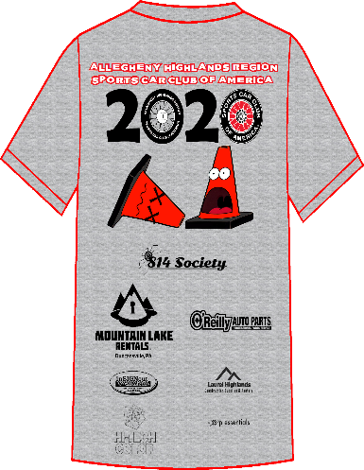

Sponsorship Levels:

Level 1 – Season Title Sponsor
$2,000
INCLUDES:
- Only one Season Title Sponsor allowed per AHR-SCCA Season.
- Your company’s logo/name as Season Title Sponsor headlined for our 2022 season. Ex: 2022 Allegheny Highlands Region ACME Autocross/Road Rally.
- Your company’s logo/name on our season t-shirts.
- Advertisements throughout each event on our Public Address system. Ad details provided by sponsor.
- Your logo/name on event “trophies”.
- Your company’s banner displayed at each event (provided by sponsor).
- Display space available for company brochures, merchandise and advertising (provided by sponsor).
- Large company logo/name displayed on our timing van (a focal point for both participants and spectators).
- Your company logo/name displayed on a minimum of 5 competition vehicles at each event (optional).
- Your company logo/name displayed on our website at www.ahr-scca.com with a hyperlink to your business website (if available).
- First chance at being the Season Title Sponsor for the following season.
- Two free season t-shirts.
- Two free competition entries.
- Additional exposure at other AHR-SCCA activities.
- Unlimited coupons for $5 off registration at club event
Level 2 – Winner’s Circle
$1,000
INCLUDES:
- Your company’s name/logo on our season t-shirts.
- Advertisements throughout each event on our Public Address system. Ad details provided by sponsor.
- Your company’s banner displayed at each event (provided by sponsor).
- Display space available for company brochures and advertising (provided by sponsor).
- Large company logo/name displayed on our timing van (a focal point for both participants and spectators).
- Your company logo/name displayed on our website at www.ahr-scca.com with a hyperlink to your business website (if available).
- Two free season t-shirts.
- Two free competition entries.
- Additional exposure at other AHR-SCCA activities.
- Unlimited coupons for $5 off registration at club events.
Level 3 – Checkered Flag
$750
INCLUDES:
- Your company’s name/logo on our season t-shirts.
- Recognition of your company throughout each event on our Public Address system.
- Display space available for company brochures and advertising (provided by sponsor).
- Company logo/name displayed on our timing van (a focal point for both participants and spectators).
- Your company logo/name displayed on our website at www.ahr-scca.com with a hyperlink to your business website (if available).
- Two free season t-shirts.
- Additional exposure at other AHR-SCCA activities.
- Unlimited coupons for $5 off registration at club events.
Level 4 – Green Flag
$500
INCLUDES:
- Your company’s name/logo on our season t-shirts.
- Recognition of your company throughout each event on our Public Address system.
- Display space available for company brochures and advertising (provided by sponsor).
- Company logo/name displayed on our timing van (a focal point for both participants and spectators).
- Your company logo/name displayed on our website at www.ahr-scca.com with a hyperlink to your business website (if available).
- One free season t-shirt.
- Additional exposure at other AHR-SCCA activities.
- Five coupons for $5 off any AHR event registration.

Level 5 – Pin Turn
$250
INCLUDES:
- Recognition of your company throughout each event on our Public Address system.
- Company logo/name displayed on our timing van (a focal point for both participants and spectators).
- Your company logo/name displayed on our website at www.ahr-scca.com with a hyperlink to your business website (if available).
- Additional exposure at other AHR-SCCA activities.

Level 6 – Starting Line
$100
INCLUDES:
- Recognition of your company throughout each event on our Public Address system.
- Your company logo/name displayed on our website at www.ahr-scca.com with a hyperlink to your business website (if available).
- Additional exposure at other AHR-SCCA activities.
- Two coupons for $5 off registration at any AHR event
Level 7 – Grid
$50
INCLUDES:
- Your company logo/name displayed on our website at www.ahr-scca.com with a hyperlink to your business website (if available).
Level 8 – Super Fan
$25
INCLUDES:
- Your name displayed on our website sponsor page at www.ahr-scca.com.
- Open to Individual, non-corporate sponsors.

*Slight changes may be made to the advertisements regarding sponsor arrangement and picture choice, pictures showing more action/movement may be added.

Worker and Driver Giveaways are ALWAYS appreciated!
- Donate gift certificates or tangible items to be gifted as awards or at our banquet.
- Have your name mentioned at events and on our website.
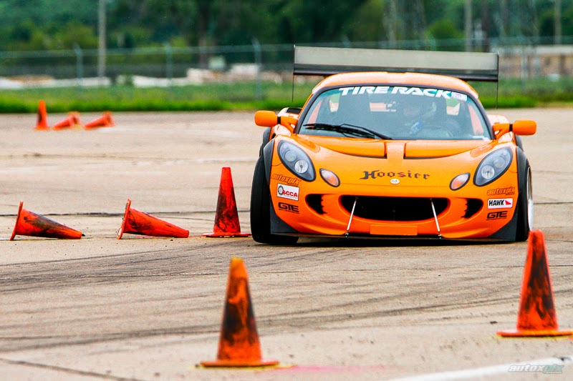
Additional Sponsorship Opportunity!
Driver's Challenge Sponsor $500
What is the Driver's Challenge?
The Driver's Challenge is an event that is held once a year towards the end of the season. Over the course of our events and throughout the season, drivers place in their individual classes for each event. The top drivers of each class then have an opportunity to compete against drivers from other classes in a neutral vehicle. At the end of the event, one driver will win the challenge.
There can be more than one sponsor for the Driver's Challenge. The Title Sponsor for this event will be on a first come, first-serve basis, and the event will be named after the initial sponsor (i.e. "Your Company" Driver's Challenge).
Driver’s Challenge Sponsorship Includes:
- Mention as Event Sponsor on on our website at www.ahr-scca.com
- Your Logo on both sides of the Challenge Vehicle
- Company Logo on any printed advertisements
- Company mentioned during the event over the public address system

Your Sponsorship goes toward, but is not limited to, the following:
- Trophies and awards
- T-shirts
- Advertising
- Rental of Challenge vehicle
Allegheny Highlands Region SCCA
Sponsorship Agreement
By signing this document, you acknowledge the information provided and agree to the terms set within the specific sponsorship level chosen. You hereby agree to sponsor the Allegheny Highlands Region of the Sports Car Club of America for the 2022 season.
The funds/products being donated to AHR-SCCA are to be used for the sole purpose of benefiting the club, club activities and its participants. In no way shall any single member of AHR-SCCA benefit from funds provided. These funds must be received by April 11, 2022. For the Driver’s Challenge, funds must be received 30 days prior to the event.
Please contact our Sponsorship Chairperson at 814-571-2864 if you have additional questions.
Sponsorship Level: _______or Driver’s Challenge: _____or Tangible items:______
T-shirt sizes (for Sponsorship levels 1, 2, 3, and 4): __________________________
Company Name: ____________________________________________________
Contact Name: ______________________________________________________
Address: ___________________________________________________________
City: ____________________________ State: _________ Zip: _______________
Contact Phone: ______________________________________________________
Website URL: http:// _________________________________________________
E-mail: _____________________________________________________________
Signature: _________________________________ Date:____________________
(By signing above, I certify that I understand and agree to the conditions set forth by both parties for the agreed sponsorship during the 2022 season)
SCCA Member to complete portion below upon receipt and return a copy to Sponsor for their records/tax purposes
AHR-SCCA Member Name: ____________________________________________
Signature: __________________________________Date: ___________________
Please Remit To:
Allegheny Highlands Region SCCA
P.O. Box 361, Duncansville, PA 16635

