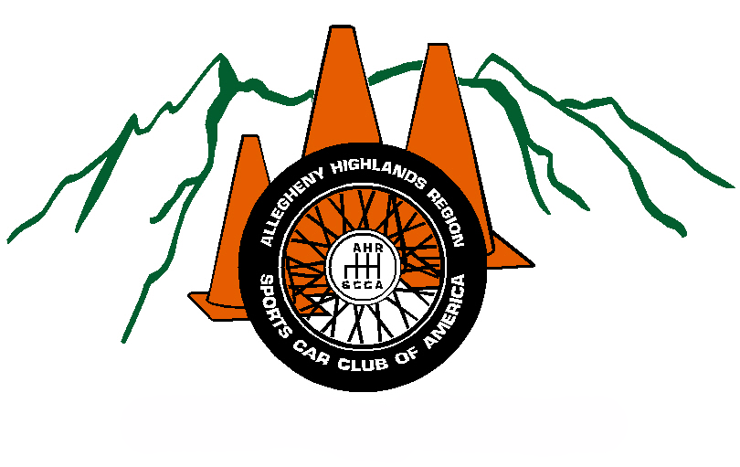

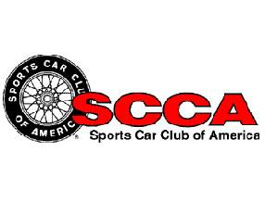

ALLEGHENY HIGHLANDS REGION

Sponsorship
Information

2016 Season

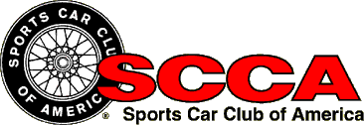 Allegheny Highlands Region

The Allegheny Highlands Region of the Sports Car Club of America would like you to consider sponsorship of our region’s events for the 2016 Summer and Fall Autocross Series. The following is some general information about our region, goals for the 2016 season and information on sponsorship options.

Demographics

SCCA Demographics:
Membership: Approx. 60,000
Male: 79%
Female: 21%

The SCCA conducts more than 2,000 amateur and professional motorsports events each year.

Region Demographics:
Region Members: 95+
Average Event Attendance: ~100
Average Event Participants: ~35

Club Goals: 2016 Season

- Boost Club awareness through active recruitment forums such as mall displays, car show participation, radio spots, posters and pamphlets.
- Raise event participation.
- Raise level of sponsorship for benefit of event participants, i.e., trophies for all events, not just limited to year-end trophies and awards.
- Increased sponsorship for purchase of new equipment for Club events.

The proposed forms of advertising for the 2016 season include, but are not limited to: posters, flyers, business cards, brochures, radio spots, newspaper listings, and many more. Sponsorship levels 1-4 will be included in all forms of advertising when applicable. Level 5 will only be displayed on the website and mentioned during the events.

The item that is aimed to boost continued participation at AHR-SCCA events is the event trophy. It is more likely for a person or persons to return and participate at an event if it is known of the possibility of walking away from the event with something in their hand. Slight changes may be made to the advertisements regarding sponsor arrangement and picture choice, pictures showing more action/movement may be added.

Example Advertisements:
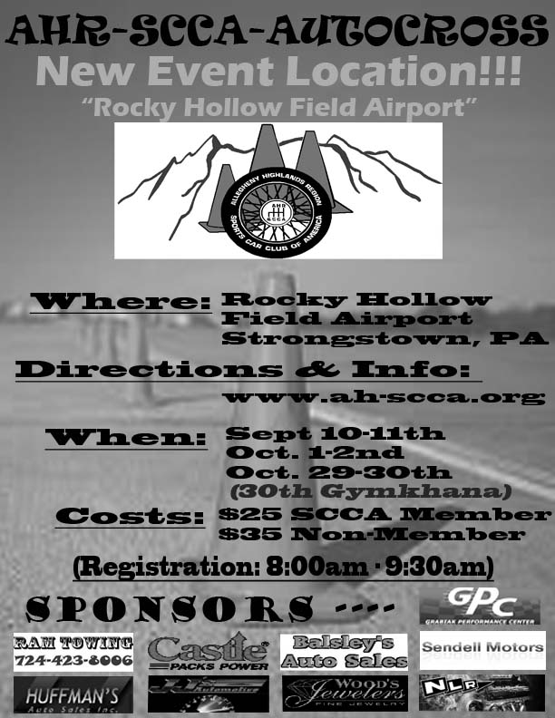
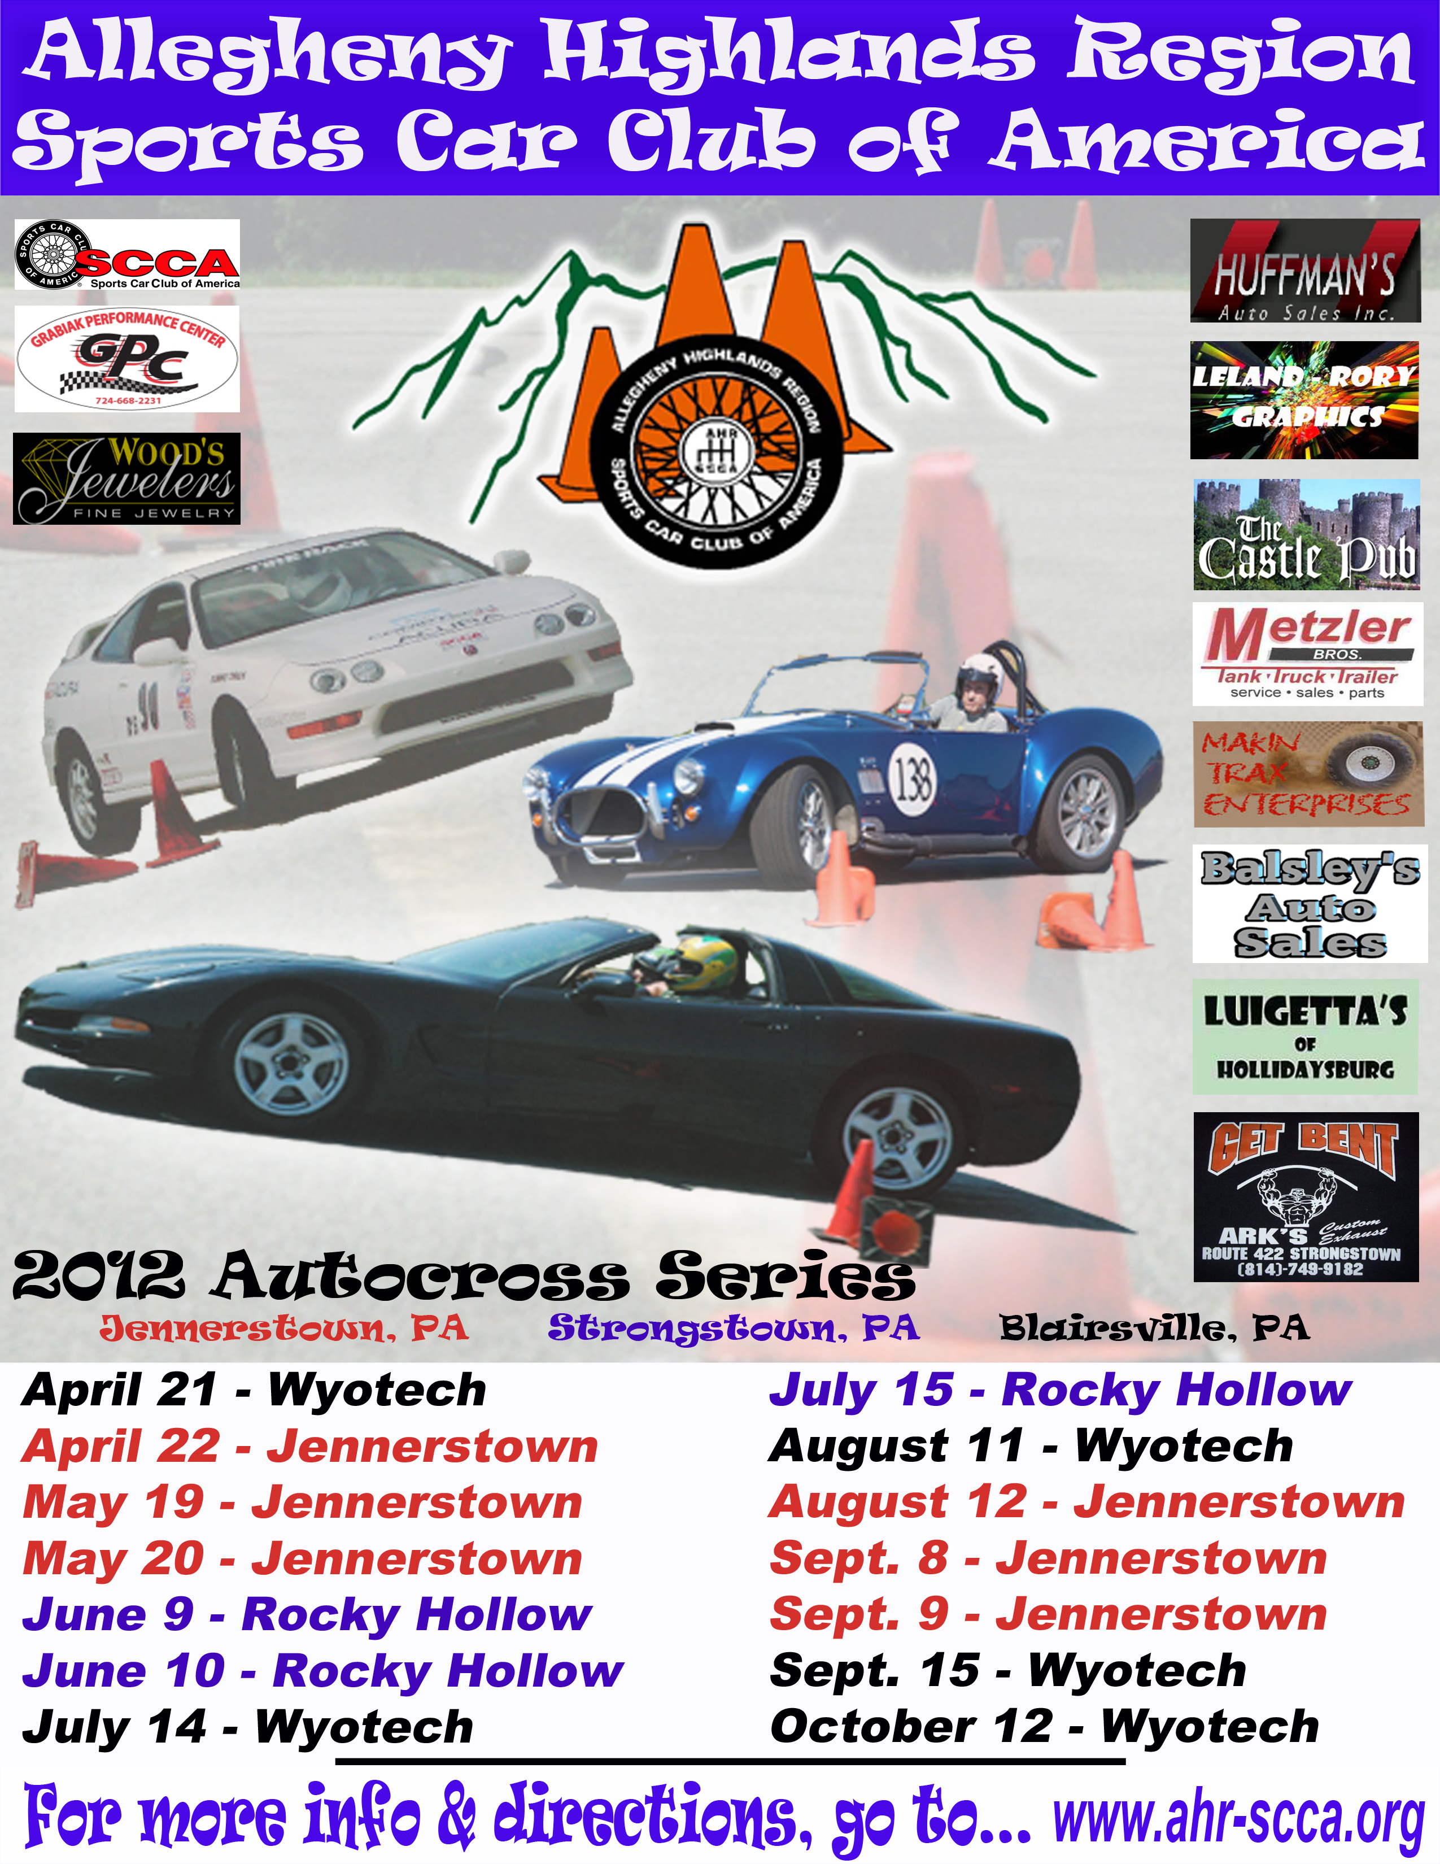

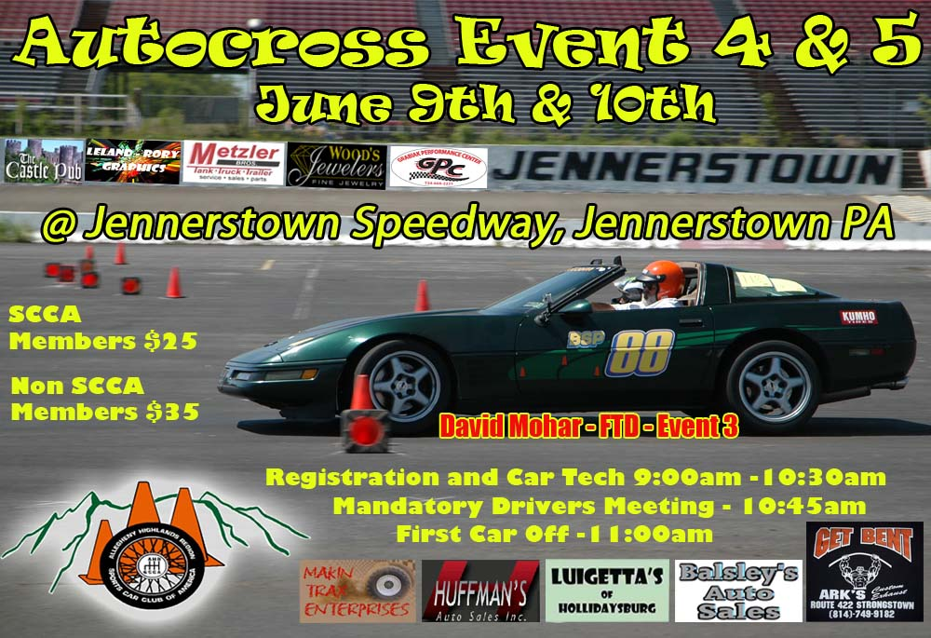

Areas that advertising will be distributed:

Blairsville
New Alexandria
Indiana
Latrobe
Greensburg
Derry
Johnstown
Somerset
Altoona
Ebensburg
Bedford
Ligonier

General Information

Sports Car Club of America, Incorporated bylaws (effective July 1, 2000)

Section 2. Purposes. The nature of the activities to be conducted and the purposes to be promoted and carried out are as follows: To promote interest in sports cars and other fine automobiles and to encourage their safe and skillful operation, by developing, arranging and regulation closed circuit road racing, rallying, and other forms of automotive competition by dissemination of information through news releases and Club publications, and through related social recreation activities for the instruction and enjoyment of its members.

Section 5. Exempt Organization. No part of the net earnings of the Club shall inure to the benefit of, or be distributable to, its members, trustees, officers, or other private persons, except that the Club shall be authorized and empowered to pay reasonable compensation for services rendered and make payments and distribution in furtherance of the purposes set forth in Article 2, Section 2, hereof. No substantial part of the activities of the Club shall be the participation in, or intervention in (including the publishing or distribution of statements) any political campaign on behalf of any candidate for public office. Not withstanding any other provision of these bylaws, the Club shall not carry on any other activities not permitted to be carried on by a corporation exempt from Federal Income Tax under Section 501 ©(4) of the Internal Revenue code of 1986.

If you choose to sponsor (Level 1-4) the Allegheny Highlands Region of the Sports Car Club of America, we ask that you provide some form of your Company Logo, for example, a flyer with a sizeable logo or an image file on a disk for us to use for printing purposes. Any products for door prizes are welcome!

Level - 1
$1,000.00

Level One includes:

- Series name headlined by sponsor, for example, ACME Autocross Series
- Logo prominently displayed on event awards (Title Sponsor)
- Display space available during events, for sponsor’s banners and/or promotional materials (to be provided by sponsor)
- Logo and series name displayed in Club pamphlets
- Recognition of sponsor over Public Address system at each event
- Additional exposure at other AHR-SCCA activities
- Sponsor’s logo on Club T-Shirt
- Unlimited coupons for $5 off registration at Club autocrosses for the 2016 season.
- Sponsorship plaque and T-Shirt
- Two Free Autocrosses for the 2016 season
- Website logo/banner on www.ahr-scca.com hyperlink to your site (if available).

Level - 2

$750.00
Level 2 sponsorship includes:

- Name displayed on event awards
- Display space available during events, for sponsor’s banners and/or promotional materials (to be provided by sponsor)
- Name displayed in pamphlets
- Recognition of sponsor over Public Address system at each event
- Sponsor’s logo on Club T-Shirt
- Unlimited coupons for $5 off registration at Club autocrosses for the 2016 season.
- One Free Autocross for the 2016 season
- Sponsorship plaque and T-shirt
- Website logo/banner on www.ahr-scca.com hyperlink to your site (if available).

Level - 3

$500.00
Level 3 sponsorship includes:

- Name displayed on event awards
- Name displayed in event pamphlets
- Recognition of sponsor over Public Address system at each event
- Sponsor’s logo on Club T-Shirt
- Ten coupons for $5 off registration at Club autocrosses for the 2016 season.
- Sponsorship plaque and T-Shirt
- Website logo/banner on www.ahr-scca.com hyperlink to your site (if available).

Level - 4

$250.00
Level 4 sponsorship includes:

- Name displayed on event awards
- Name displayed in event pamphlets
- Recognition of sponsor over Public Address system at each event
- Sponsor’s logo on Club T-Shirt
- Ten coupons for $5 off registration at Club autocrosses for the 2016 season.
- Sponsorship plaque and T-Shirt
- Website logo/banner on www.ahr-scca.com hyperlink to your site (if available).

Level – 5

$50.00
Level 5 sponsorship includes:

- Name only (no logo/banner) displayed on the www.ahr-scca.com sponsor page hyperlinked to your site (if available)
- Two coupons for $5 off registration at Club autocrosses for the 2016 season.

Level – 6 Individual (non corporate)

$25.00
Level 6 sponsorship includes:

- Name displayed on the www.ahr-scca.com sponsor page
- One coupon for $5 off registration at Club autocrosses for the 2016 season.

DRIVER’S CHALLENGE

What is a driver’s challenge? The driver’s challenge is an event that is held once a year towards the end of the season. Over the course of events, throughout the season, drivers qualify in their individual classes for each event. The top drivers of each class then have an opportunity to compete against drivers from other classes in a neutral vehicle. At the end of the event, one driver will win the challenge.

What does my sponsorship go towards?

Your sponsorship goes towards, but not limited to:

- Trophies and Awards
- T-Shirts and Apparel
- Advertising
- Purchase or Rental of Challenge Vehicle

What do I get for my sponsorship?

- Mention as event sponsor on www.ahr-scca.org
- Company logo on any print advertisements
- Company mentioned during the event over our PA system

There can be more than one sponsor for the Driver’s Challenge. The title sponsor will be first come first served and the event will be named after the initial sponsor. i.e. your company Driver’s Challenge. The cost of this sponsorship will be $500.00 or donation of challenge vehicle.

2012 Challenge Sponsor

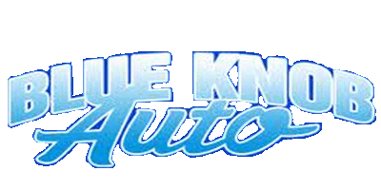

2013/2014 Challenge Sponsor 2015 Challenge Sponsor
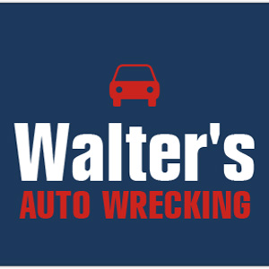

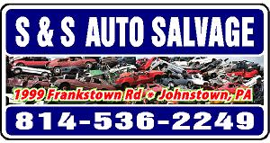

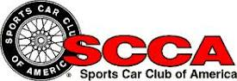

Sponsorship Agreement

By signing this document, you acknowledge the information provided and agree to the terms set within the specific sponsorship level chosen. You hereby agree to sponsor the Allegheny Highlands Region of the Sports Car Club of America for the 2016 season and/or driver’s challenge.

The funds/products being donated to AHR-SCCA are to be used for the sole purpose of benefiting the club, club activities, and its participants. In no way shall any single member of AHR-SCCA benefit from the funds provided. These funds must be received by April 1st.

Sponsorship Level_______

Company Name: ______________________________________________________

Contact Name: _______________________________________________________

Address: ____________________________________________________________

City: _____________________________ State: ______ Zip: __________________

Contact Phone #: _____________________________________________________

Website URL: http://___________________________________________________

E-Mail: _____________________________________________________________

Signature: ___________________________________________________________
(By signing above, I certify that I understand and agree to the conditions set forth by both parties for the agreed sponsorship during the 2016 season)

Date: _____________________

AHR-SCCA Member Name: _____________________________________________

Signature: ___________________________________________________________

Date: ______________________
For AHR-SCCA Records
Please Remit To:
P.O. Box 361, Duncansville, PA 16635

Sponsorship Agreement

By signing this document, you acknowledge the information provided and agree to the terms set within the specific sponsorship level chosen. You hereby agree to sponsor the Allegheny Highlands Region of the Sports Car Club of America for the 2016 season and/or driver’s challenge.

The funds/products being donated to AHR-SCCA are to be used for the sole purpose of benefiting the club, club activities, and its participants. In no way shall any single member of AHR-SCCA benefit from the funds provided. These funds must be received by April 1st.

Sponsorship Level_______

Company Name: ______________________________________________________

Contact Name: _______________________________________________________

Address: ____________________________________________________________

City: _____________________________ State: ______ Zip: __________________

Contact Phone #: _____________________________________________________

Website URL: http://___________________________________________________

E-Mail: _____________________________________________________________

Signature: ___________________________________________________________
(By signing above, I certify that I understand and agree to the conditions set forth by both parties for the agreed sponsorship during the 2016 season)

Date: _____________________

AHR-SCCA Member Name: _____________________________________________

Signature: ___________________________________________________________

Date: ______________________
For Sponsor Records

